

**Basics of Python Laboratory**

**(BCS222)**

BTech CSE 2nd Semester

Practical File

**SUBMITTED TO: SUBMITTED BY:**

Ms. Simranjot Kaur Name:Kulvir Singh Saggu

Assistant Professor RollNo.:GU-2021-4246

**Table of Contents**

|  |  |  |
| --- | --- | --- |
| **SR. NO.** | **AIM** | **PAGE NO.** |
| 1. | Write a python program to calculate the area of a rectangle by assigning values to length and breadth as well as taking input from the user. | 1 |
| 2. | Write a python program to swap two numbers using temp variables and multiple assignments. | 2 |
| 3. | Write a python program to show the use of build in functions and methods for the following datatypes:  Numeric,String,List,Tuple,Set,Dictionary. | 3-8 |
| 4 | Write a program to find the maximum of three numbers using nested if-else statements. | 9 |
| 5 | Write a program to prompt a user to enter a day of the week. If the entered day of the week is between 1 and 7, then display the respective name of the day. | 10 |
| 6 | Write a program to find the sum of digits of a number using a while loop. | 11 |
| 7 | Write a program to find the factorial of a number using a for loop. | 12 |
| 8 | Write a program to print numbers between 0 to 10 except 7 and 8. | 13 |
| 9 | Write a program to create a dictionary of the name and age of five employees, take the input from the user and display the age corresponding to the name. | 14 |
| 10 | Write a program to check whether a given number is an Armstrong number or not. | 15 |
| 11 | Write a python function that returns a maximum of two numbers. | 16 |
| 12 | Write a python function that calculates the factorial of a number. | 17 |
| 13 | Write a function that returns the area and perimeter of a rectangle | 18 |
| 14 | Write a python program to print different patterns. | 19 |
|  |  |  |
|  |  |  |
|  |  |  |
|  |  |  |

**PRACTICAL 1 : WRITE A PYTHON PROGRAM TO CALCULATE THE AREA OF A RECTANGLE BY ASSIGNING VALUES TO LENGTH AND BREADTH AS WELL AS TAKING INPUT FROM THE USER.**

**1.**

length = 40

breadth = 2

area = length * breadth

print(area)

**OUTPUT:**

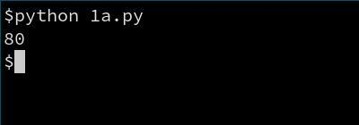

length = int(input("Enter length : "))

breadth = int(input("Enter breadth : "))

area = length * breadth

print(area)

**OUTPUT:**

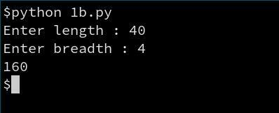

**PRACTICAL 2 : WRITE A PYTHON PROGRAM TO SWAP TWO NUMBERS USING TEMP VARIABLES AND MULTIPLE ASSIGNMENTS.**

a = 10

b = 20

print("Before swapping ",a,b)

temp = a

a = b

b = temp

print("After swapping ",a,b)

**OUTPUT:**

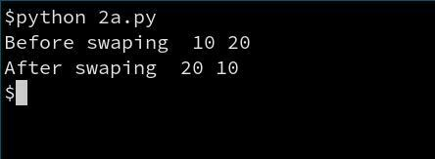

a = 10

b = 20

print("Before swapping ",a,b,)

a , b = b , a

print("After swapping ",a,b)

**OUTPUT:**

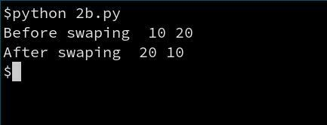

**PRACTICAL 3 : WRITE A PYTHON PROGRAM TO SHOW THE USE OF BUILD IN FUNCTIONS AND METHODS FOR THE FOLLOWING DATA TYPES:NUMERIC,STRING,LIST,TUPLE,SET,DICTIONARY.**

#numeric functions

num = 8

print(type(num))

num = 3.45

print(type(num))

num = 2+4j

print(type(num))

**OUTPUT:**

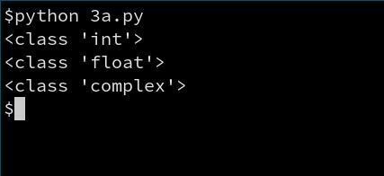

#String functions

str1='Hello World!'

str2="bye World!"

str3="""I

Love

Python"""

print(str1,type(str1))

print(str2,type(str2))

print(str3,type(str3))

print(str1[2:])

print(str1.count("l"))

print(str1.upper())

print(str1.lower())

print(str1.replace("Hello","Bonjour"))

print(str1.split())

print(str1.title())

**OUTPUT:**

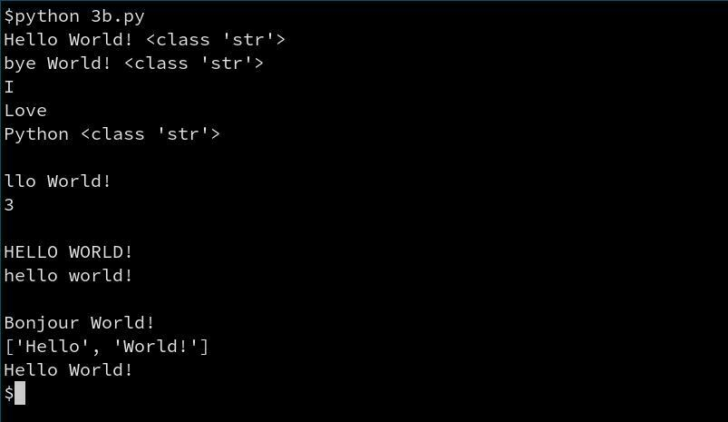

#list

lst = [1,4,7,9,14,18]

print(lst,type(lst))

lst.append(22)

print(lst)

print("max is : ",max(lst))

print("min is : ",min(lst))

lst.insert(1,5)

print(lst)

print(lst.count(9))

lst.remove(22)

print(lst)

print(lst.index(7))

lst.reverse()

print(lst)

**OUTPUT:**

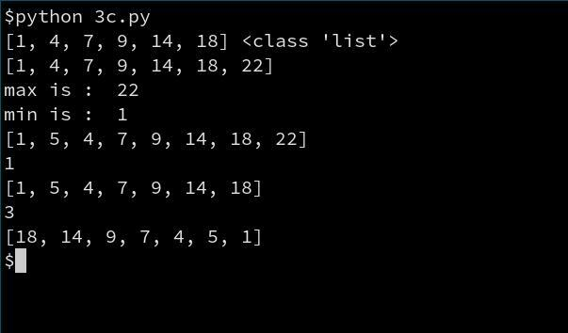

#Tuple

t=(1,3,6,9,11,14,18)

print(t)

print(type(t))

print(t[2:5])

print(len(t))

print(max(t))

print(min(t))

**OUTPUT:**

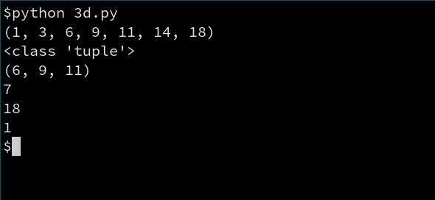

#sets

s1={0,1,2,3,4,5,6,7}

s2={5,6,7,8,9}

print(s1,s2)

s2.add(10)

print(s2)

s2.remove(10)

print(s2)

print(s1.issubset(s2))

print(s2.issuperset(s1))

#union of two sets

print(s1|s2)

#intersect of two sets

print(s1&s2)

#differences of two sets

print(s2.difference(s1))

#symmetric difference of two sets

print(s1^s2)

**OUTPUT:**

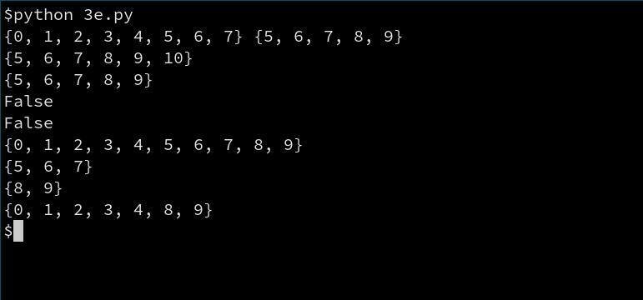

#DICTIONARY

BOOK_NAME_AND_AUTHORS={"Let Us Python":"Yashavant Kanetkar","Python Crash Course":"Eric Matthes"}

print(len(BOOK_NAME_AND_AUTHORS))

print(BOOK_NAME_AND_AUTHORS.get("Let Us Python"))

print(BOOK_NAME_AND_AUTHORS.keys())

print(BOOK_NAME_AND_AUTHORS.items())

print(BOOK_NAME_AND_AUTHORS.values())

print(sorted(BOOK_NAME_AND_AUTHORS))

BOOK_NAME_AND_AUTHORS.popitem()

print((BOOK_NAME_AND_AUTHORS))

**OUTPUT:**

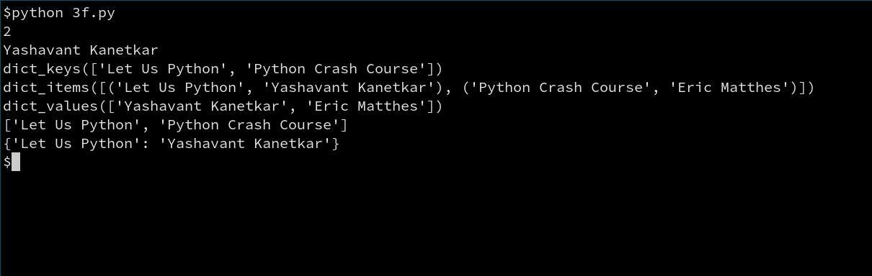

**PRACTICAL 4 : WRITE A PROGRAM TO FIND THE MAXIMUM OF THREE NUMBERS USING NESTED IF-ELSE STATEMENTS.**

n1=int(input("Enter number 1 : "))

n2=int(input("Enter number 2 : "))

n3=int(input("Enter number 3 : "))

if n1>n3:

if n1>n2:

print(n1,"is biggest of all")

else:

print(n2,"is biggest of all")

else:

if n3>n2:

print(n3,"is biggest of all")

else :

print(n2,"is biggest of all")

**OUTPUT:**

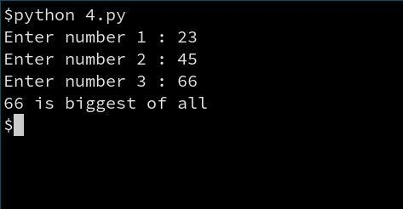

**PRACTICAL 5 : WRITE A PROGRAM TO PROMPT A USER TO ENTER A DAY OF THE WEEK. IF THE ENTERED DAY OF THE WEEK IS BETWEEN 1 AND 7, THEN DISPLAY THE RESPECTIVE NAME OF THE DAY.**

inp=int(input("Enter the day of week in number : "))

if inp == 1:

print("Monday")

elif inp == 2:

print("Tuesday")

elif inp == 3:

print("Wednesday")

elif inp == 4:

print("Thursday")

elif inp == 5:

print("Friday")

elif inp == 6:

print("Saturday")

elif inp == 7:

print("Sunday")

else :

print("Invalid input")

**OUTPUT:**

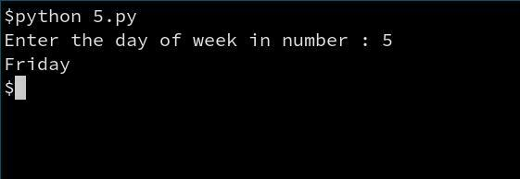

**PRACTICAL 6 : WRITE A PROGRAM TO FIND THE SUM OF DIGITS OF A NUMBER USING A WHILE LOOP.**

inp = int(input("Enter number : "))

temp = inp

sum = 0

while (temp != 0):

sum+=temp%10

temp//=10

print("sum of digits of",inp,"is",sum)

**OUTPUT:**

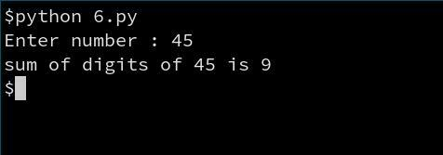

**PRACTICAL 7 : WRITE A PROGRAM TO FIND THE FACTORIAL OF A NUMBER USING A FOR LOOP.**

inp = int(input("Enter the number you want to find the factorial of : "))

fact=1

for i in range(inp):

fact *= inp

inp -= 1

print(fact)

**OUTPUT:**

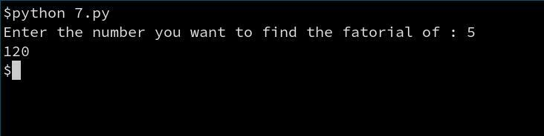

**PRACTICAL 8 : WRITE A PROGRAM TO PRINT NUMBERS BETWEEN 0 TO 10 EXCEPT 7 AND 8.**

for i in range(1,11):

if i == 7 or i == 8:

continue

else:

print(i)

**OUTPUT:**

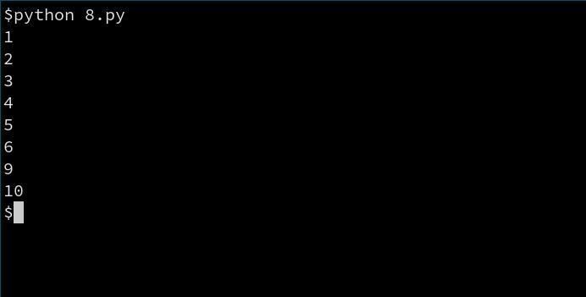

**PRACTICAL 9 :WRITE A PROGRAM TO CREATE A DICTIONARY OF THE NAME AND AGE OF FIVE EMPLOYEES, TAKE THE INPUT FROM THE USER AND DISPLAY THE AGE CORRESPONDING TO THE NAME.**

d={"vishal":20,

"aman":19,

"rahul":21,

"kumar":18,

"joshi":20}

inp = input("Enter the name you want to know age of : ")

print(d[inp])

**OUTPUT:**

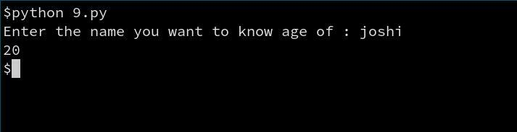

**PRACTICAL 10 : WRITE A PROGRAM TO CHECK WHETHER A GIVEN NUMBER IS AN ARMSTRONG NUMBER OR NOT.**

num = int(input("Enter a number: "))

sum = 0

temp = num

while temp > 0:

digit = temp % 10

sum += digit ** 3

temp //= 10

if num == sum:

print(num,"is an Armstrong number")

else:

print(num,"is not an Armstrong number")

**OUTPUT:**

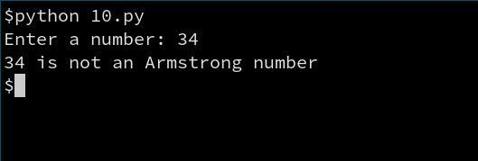

**PRACTICAL 11 : WRITE A PYTHON FUNCTION THAT RETURNS A MAXIMUM OF TWO NUMBERS.**

def find_max(a,b):

if a>b:

return b

else:

return a

print(find_max(1,2))

**OUTPUT:**

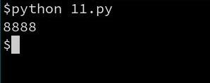

**PRACTICAL 12 : WRITE A PYTHON FUNCTION THAT CALCULATES THE FACTORIAL OF A NUMBER.**

def facto(a):

fact=1

while (a>0):

fact *= a

a-=1

return fact

print(facto(5))

**OUTPUT:**

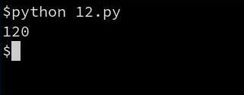

**PRACTICAL 13 :WRITE A FUNCTION THAT RETURNS THE AREA AND PERIMETER OF A RECTANGLE**

def rectangle_area_perimeter(a,b):

area = a*b

perimeter = 2*area

print("area of rectangle is",area,"\nperimeter if rectangle is",perimeter)

rectangle_area_perimeter(4,4)

**OUTPUT:**

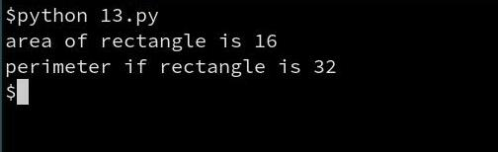

**PRACTICAL 14 :WRITE A PYTHON TO PRINT DIFFERENT PATTERNS.**

for i in range(5):

for j in range(i):

print(i+1,end='')

print()

**OUTPUT:**

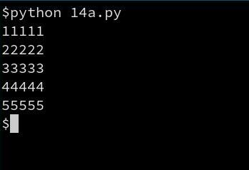

for i in range(5):

for j in range(i+1):

print(i+1,end='')

print()

**OUTPUT:**

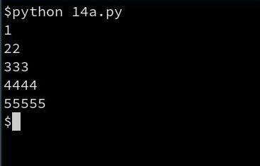

al=”ABCDE”

for i in range(5):

for j in range(i+1):

print(al[i],end='')

print()

